Design below class & implement doDeposit() & doWithdrawal() methods

During withdrawal of amount if balance becomes less than 5000/= ,

then raise InsufficientFundException.

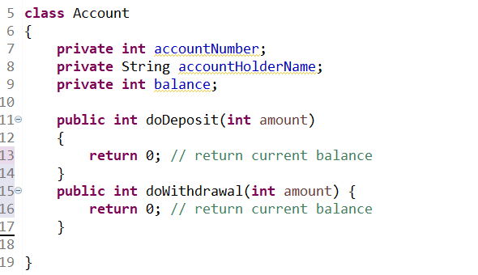

Sample Output

